**EX.NO:11B DATE:**

**AIM:**

**ARITHMETIC OPERATIONS USING RPC**

To Develop a simple calculator using XMLRPC

**ALGORITHM:**

# Server.py

1. Import XMLRPCServer package
2. Define functions for addition, subtraction, multiplication, division and modulus
3. Initialize simple XMLRPCServer with IP address (or localhost) and port number
4. Register the functions add, sub, mul, div and mod with the server
5. Handle the request
6. Close the connection

# Client.py

1. Import XMLRPC Client package
2. Define functions for addition, subtraction, multiplication, division and modulus
3. Initialize simple XMLRPC Client with Server IP address (or localhost) and port number
4. Get two numbers a and b for arithmetic operations
5. Call add() function and print the result
6. Call sub() function and print the result
7. Call mul() function and print the result
8. Call div() function and print the result
9. Call mod() function and print the result
10. Close the connection

# Code:

**server.py**

from xmlrpc.server import SimpleXMLRPCServer

# Define arithmetic functions def add(a, b):

return a + b

def sub(a, b): return a - b

def mul(a, b): return a * b

def div(a, b): if b == 0:

return "Cannot divide by zero" return a / b

def mod(a, b): if b == 0:

return "Cannot perform modulus with zero" return a % b

# Initialize XML-RPC server

server = SimpleXMLRPCServer(("localhost", 8000)) print("Calculator XML-RPC server is running on port 8000...")

# Register functions with the server server.register_function(add, "add") server.register_function(sub, "sub") server.register_function(mul, "mul") server.register_function(div, "div") server.register_function(mod, "mod")

# Handle requests try:

server.serve_forever() except KeyboardInterrupt:

print("\nServer stopped.")

# client.py

import xmlrpc.client

# Connect to the XML-RPC server

server = xmlrpc.client.ServerProxy("http://localhost:8000/")

# Get two numbers from the user

a = float(input("Enter the first number: "))

b = float(input("Enter the second number: "))

# Perform operations and display results try:

print(f"Addition of {a} and {b}: {server.add(a, b)}") print(f"Subtraction of {a} and {b}: {server.sub(a, b)}") print(f"Multiplication of {a} and {b}: {server.mul(a, b)}") print(f"Division of {a} by {b}: {server.div(a, b)}")

print(f"Modulus of {a} and {b}: {server.mod(a, b)}") except Exception as e:

print("Error:", e)

python Server.py python Client.py

OUTPUT:

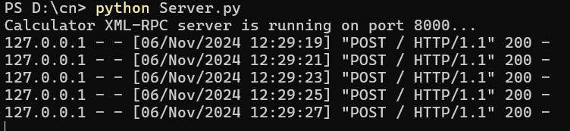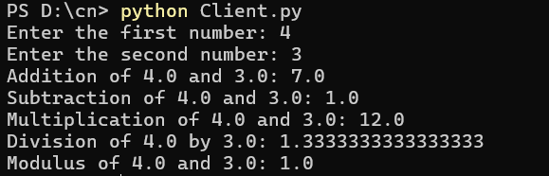

RESULT:

Hence, Simple Calculator using XMLRPC has been created.